Energy Solutions Limited Visits JCM Solar Plants to Inform Irrigation and Mining Projects
29 October 2026 | Company News
Energy Solutions Limited (ESL) Co-Founder and Managing Director, Owen Chitete visited JCM Power’s Golomoti and Salima solar photovoltaic plants on Thursday, 29 October 2026, as part of the company’s efforts to strengthen its capacity to develop larger renewable energy projects.
The learning visit aimed to understand the successes and challenges involved in bringing projects of this scale from development into operation. These insights are particularly relevant as ESL pursues solar energy opportunities serving irrigation and mining, where reliable power is essential to productivity and commercial viability.
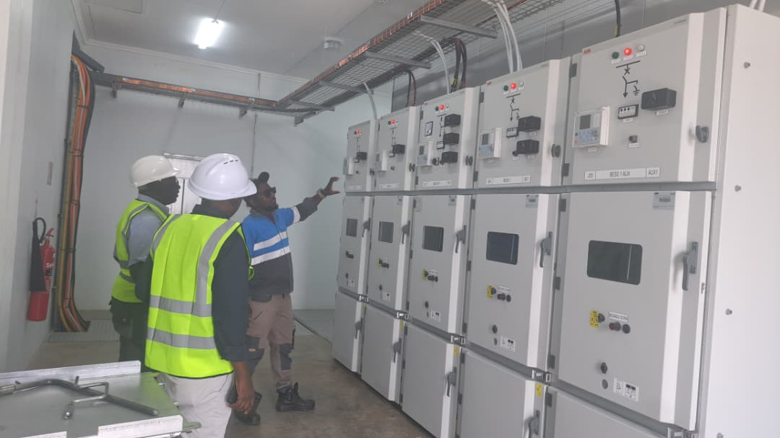
An on-site technical briefing during ESL’s learning visit to JCM Power’s Golomoti solar facilities on 29 October 2026.

Learning from established projects in Malawi
Salima and Golomoti provide valuable examples of large solar investments operating within Malawi’s energy sector. Together, the plants have a combined rated alternating-current capacity of 80 megawatts (MW), offering a useful reference for understanding the technical, financial and operational requirements of substantial renewable energy infrastructure.
The 60 MW Salima Solar PV Project, situated approximately 20 kilometres from Salima town, occupies a 168-hectare site. It became Malawi’s first solar independent power producer and entered commercial operation in 2021. The plant uses single-axis tracking technology, which allows solar panels to follow the sun’s movement to improve energy capture.
The 20 MW Golomoti Solar PV Project, in Dedza District, combines a 28.5 MWp solar array with a lithium-ion battery energy storage system rated at 5 MW/10 MWh. Developed by JCM Power, Golomoti entered commercial operation in March 2022, following construction completed in under 12 months. It represents an important example of integrating solar generation and battery storage in Malawi.

Relevance to irrigation and mining
For ESL, the visit forms part of a broader commitment to grounding project development in practical experience. Understanding how established facilities were developed and are operated can help inform decisions on feasibility studies, engineering, financing, construction and maintenance.
In irrigation, solar energy can support water pumping and agricultural production. Successful projects require careful alignment between available water resources, pumping requirements, seasonal cropping patterns and the timing of electricity generation.
Mining applications present their own demands, including equipment starting loads, changing operating conditions and the need for dependable electricity. Assessing solar generation alongside storage, grid supply or other power sources is therefore essential to developing solutions suited to each operation.
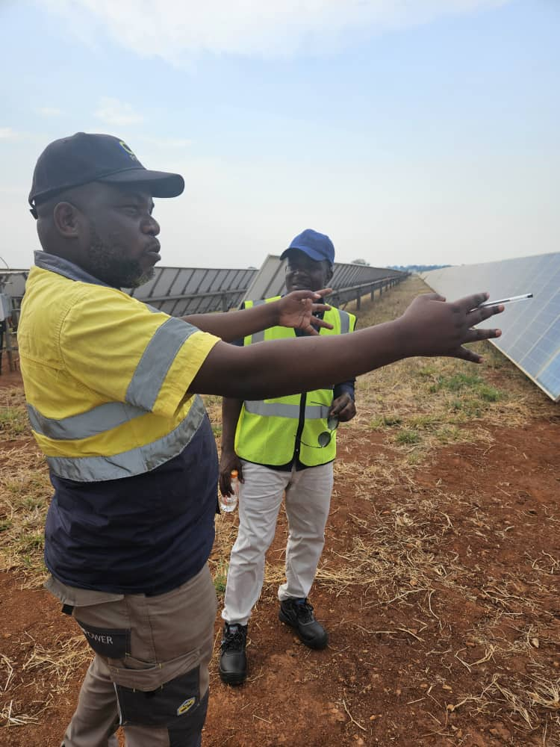
An exchange beside the solar arrays during the learning visit.
The experience of projects such as Salima and Golomoti also provides a useful reference for considering land requirements, environmental and social responsibilities, community engagement, safety and long-term asset management. These considerations influence both investment readiness and sustained operational performance.

Strengthening project preparation
As ESL advances its irrigation and mining energy initiatives, learning from operational projects will help the company frame better questions, identify development risks earlier and engage more effectively with technical partners and prospective financiers.
Energy Solutions Limited extends its appreciation to JCM Power and the teams at Golomoti and Salima for hosting the visit and supporting knowledge exchange within Malawi’s renewable energy sector.
The visit reflects ESL’s commitment to building the knowledge, partnerships and project preparation capacity needed to deliver reliable solar solutions for productive sectors of the economy.

