Energy Solutions Ltd MD Attends 2026 Malawi National Energy Conference
Learning from renewable energy experts to support Malawi’s development
Salima, Malawi | 30 September to 2 October 2026
Energy Solutions Limited (ESL) was represented by its Co-Founder and Managing Director, Owen Chitete, at the 2026 Malawi National Energy Conference in Salima. His attendance provided an important opportunity to learn from renewable energy experts and consider how energy solutions can support productive investment, stronger public services and economic development in Malawi.
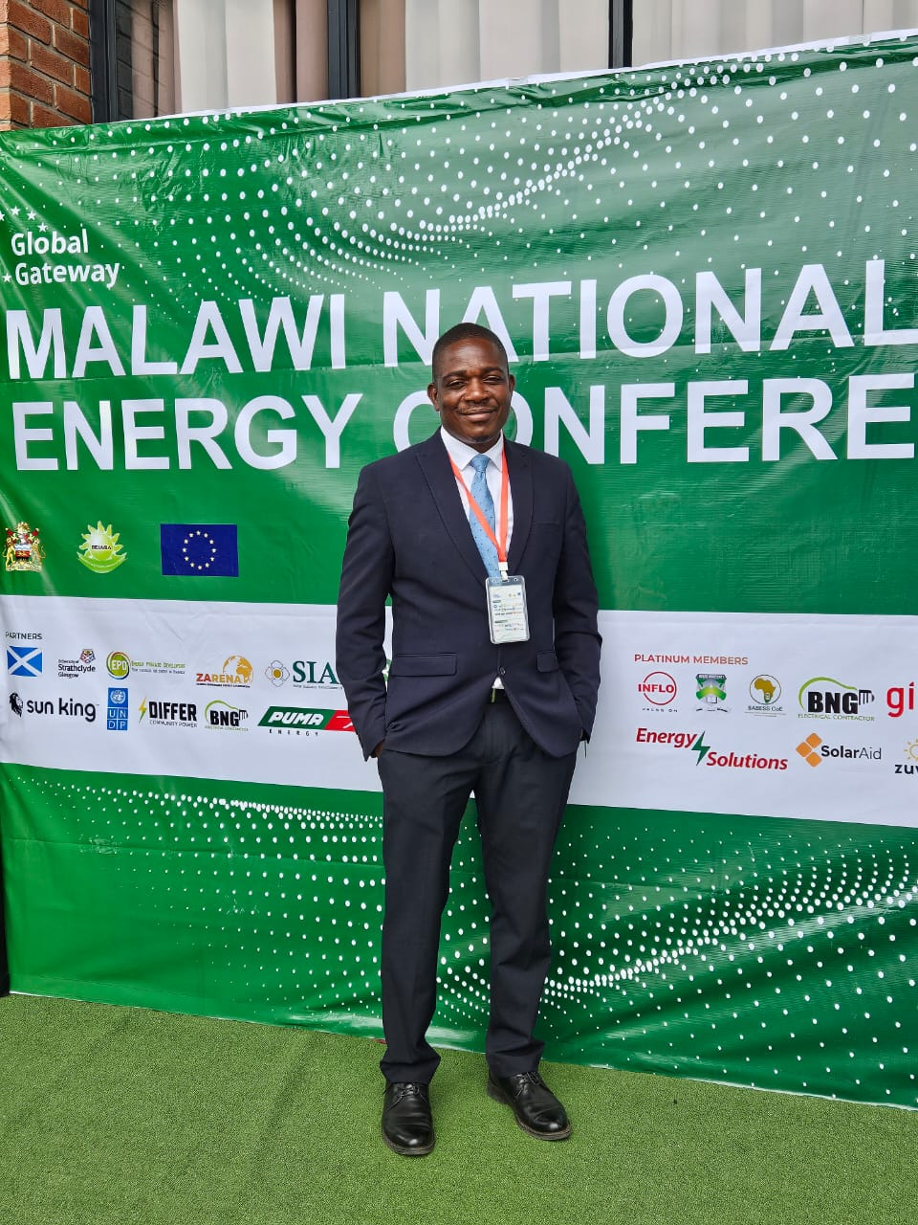
Owen Chitete, Co-Founder and Managing Director of Energy Solutions Limited, at the 2026 Malawi National Energy Conference.
Organised by the Renewable Energy Industries Association of Malawi (REIAMA), the conference took place from 30 September to 2 October 2026 at the Sunbird Livingstonia International Conference Centre in Salima. Its theme, “Powering Growth: Mainstreaming Energy Across Sectors”, placed energy at the centre of Malawi’s wider development agenda.

Energy as a driver of development
For ESL, the value of participating lay in exploring how renewable energy can improve the activities that people and businesses depend on. Reliable power supports irrigation, agricultural processing, industrial production and essential services. Understanding these applications helps energy companies develop systems around customers’ operating needs and the economic benefits they seek to achieve.
The conference had four main pillars namely, integrating energy into policy and sector planning,powering healthcare and education, supporting agriculture and commercial activity and Financing sustainable energy projects. These provide a useful basis for understanding the issues on the agenda and their relevance to ESL’s work.
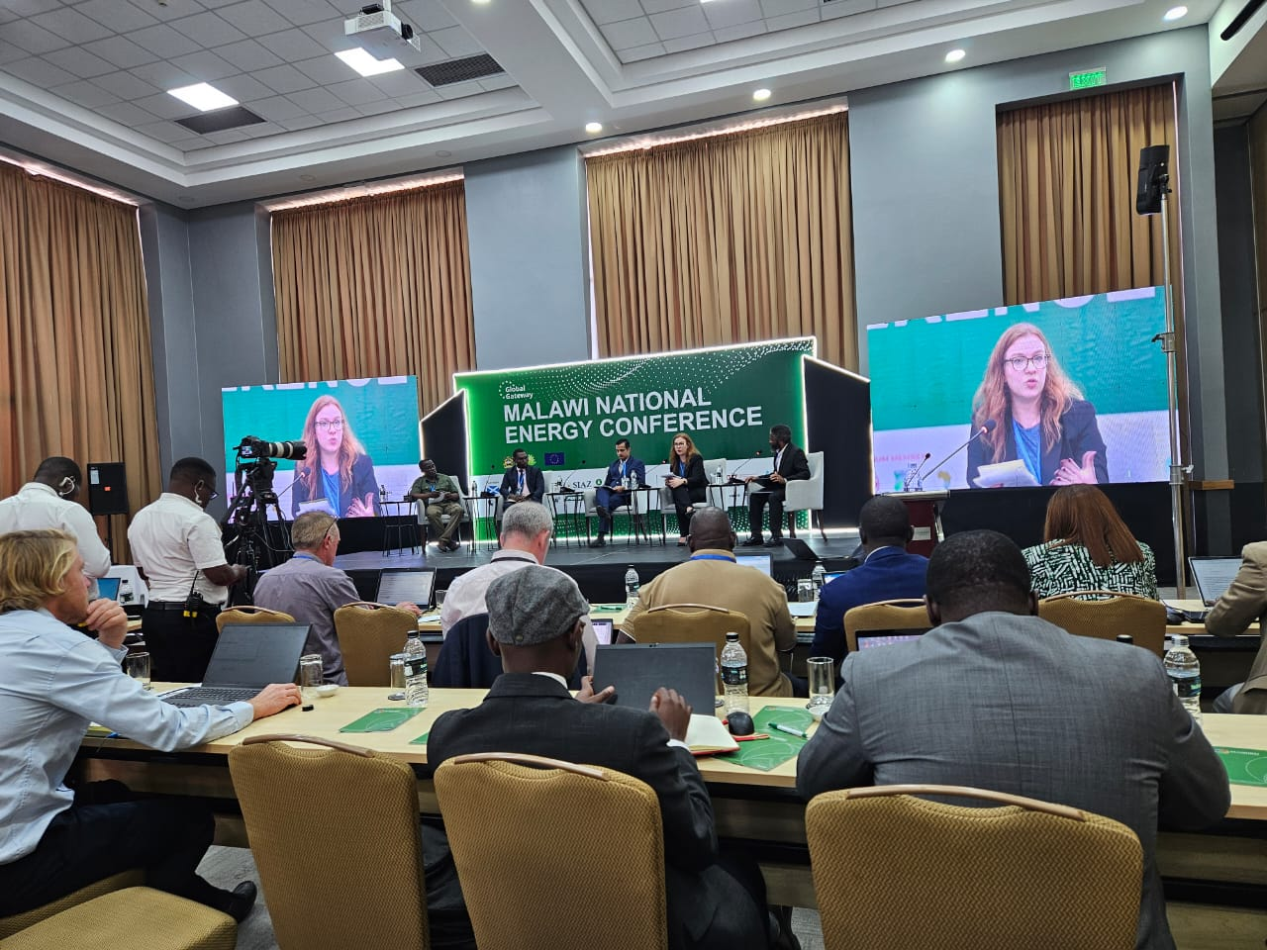
A panel session at the 2026 Malawi National Energy Conference in Salima.

Bringing the learning into ESL’s work
Mr Chitete’s participation gave ESL a platform to learn from specialist perspectives and examine opportunities for collaboration across the renewable energy sector. The conference’s focus on productive uses of energy is particularly relevant as the company explores solar irrigation and energy opportunities associated with mining and other commercial activities.
For ESL, a central lesson is that successful energy projects require an understanding of the wider activity they serve. An irrigation scheme needs an appropriate water supply and a viable farming operation alongside its pumping system. A commercial installation needs to match the customer’s demand and operating schedule. Financing and technical design must therefore be considered together.
Participation in the conference supports ESL’s continuing efforts to strengthen its knowledge and develop practical energy solutions for Malawi. By applying this learning to project development and customer service, the company can contribute to the wider goal of using renewable energy to improve livelihoods, support enterprise and enable national development.

